Acme Consulting

Sample Business Plan
What follows is a complete business plan for a hypothetical company. It includes tables and charts embedded in the text, as they would be generated by Business Plan Pro, although because of HTML considerations they are not identical. Business Plan Pro is a product of Palo Alto Software. Click here to order and download.

1. 0 Executive Summary
Acme Consulting will be formed as a consulting company specializing in marketing of high technology products in international markets. Its founders are former marketers of consulting services, personal computers, and market research, all in international markets. They are founding Acme to formalize the consulting services they offer.
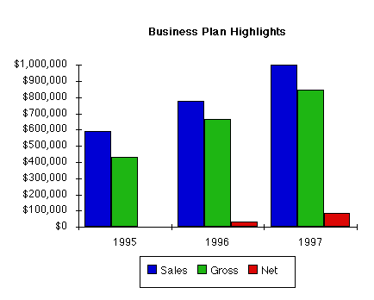

1. 2 Mission
Acme Consulting offers high-tech manufacturers a reliable, high quality alternative to inhouse resources for business development, market development, and channel development on an international scale. A true alternative to in house resources offers a very high level of practical experience, know how, contacts, and confidentiality. Clients must know that working with Acme is a more professional, less risky way to develop new areas even than working completely in house with their own people. Acme must also be able to maintain financial balance, charging a high value for its services, and delivering an even higher value to its clients. Initial focus will be development in theEuropean and Latin American markets, or for European clients in the United States market.

1. 3 Keys to Success
- Excellence in fulfilling the promise completely confidential, reliable, trustworthy expertise and information.
- Developing visibility to generate new business leads.
- Leveraging from a single pool of expertise into multiple revenue generation opportunities: retainer consulting, project consulting, market research, and market research published reports.

2. 0 Company Summary
Acme Consulting is a new company providing high-level expertise in international high-tech business development, channel development, distribution strategies, and marketing of high tech products. It will focus initially on providing two kinds of international triangles:
- Providing United States clients with development forEuropean and Latin American markets.
- Providing European clients with development for the United States and Latin American markets.
As it grows it will take on people and consulting work in related markets, such as the rest of Latin America, and the Far East, and similar markets. As it grows it will look for additional leverage by taking brokerage positions and representation positions to create percentage holdings in product results.

2. 1 Company Ownership
Acme Consulting will be created as a California C corporation based in Santa Clara County, owned by its principal investors and principal operators. As of this writing it has not been chartered yet and is still considering alternatives of legal formation.

2. 2 Startup Summary
Total start up expense (including legal costs, logo design, stationery and related expenses) come to $73,000. Start up assets required include $3,000 in short term assets (office furniture, etc.) and $1,000,000 in initial cash to handle the first few months of consulting operations as sales and accounts receivable play through the cash flow. The details are included in the table.
Start-up Plan
_______________________________
Start-up Expenses
Legal $1,000
Stationery etc. $3,000
Brochures $5,000
Consultants $5,000
Insurance $350
Expensed equipment $3,000
Other $1,000
_______________________________
Total Start-up Expense $18,350

Start-up Assets Needed
Cash requirements $25,000
Start-up inventory $0
Other Short-term Assets $7,000
Total Short-term Assets $32,000
Long-term Assets WORD DOCUMENT HAS NO NUMBER HERE
Capital Assets $0
_______________________________
Total Assets $32,000

Total Startup Requirements: $50,350
Left to finance: $0

Start-up Funding Plan

Investment
Investor 1 $20,000
Investor 2 $20,000
Other $10,000
Total investment $50,000

Short-term borrowing
Unpaid expenses $5,000
Short-term loans $0
Interest-free short-term loans $0
Subtotal Short-term Borrowing $5,000
Long-term Borrowing $0
Total Borrowing $5,000

Loss at start-up ($23,000)
Total Equity $27,000
Total Debt and Equity $32,000
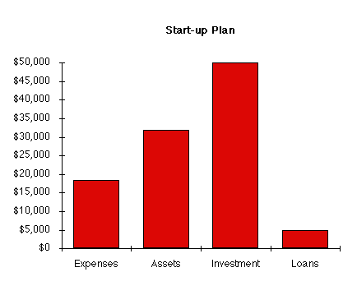

2. 3 Company Services
Acme offers expertise in channel distribution, channel development, and market development, sold and packaged in various ways that allow clients to choose their preferred relationship: these include retainer consulting relationships, project based consulting, relationship and alliance brokering, sales representation and market representation, project-based market research, published market research, and information forum events.

2. 4 Company locations and facilities
The initial office will be established in A quality office space in the Santa Clara County "Silicon Valley" area of California, the heart of the U.S. high tech industry.

3. 0 Services
Acme offers the expertise a high-technology company needs to develop new product distribution and new market segments in new markets. This can be taken as high-level retainer consulting, market research reports, or project-based consulting.

3. 1 Service Description
1. Retainer consulting: we represent a client company as an extension of its business development and market development functions. This begins with complete understanding of the client company's situation, objectives, and constraints. We then represent the client company quietly and confidentially, sifting through new market developments and new opportunities as is appropriate to the client, representing the client in initial talks with possible allies, vendors, and channels.
2. Project consulting: Proposed and billed on a per-project and per- milestone basis, project consulting offers a client company a way to harness our specific qualities and use our expertise to solve specific problems, develop and/or implement plans, develop specific information.
3. Market research: group studies available to selected clients at $5,000 per unit. A group study is packaged and published, a complete study of a specific market, channel, or topic. Examples might be studies of developing consumer channels in Japan or Mexico, or implications of changing margins in software.

3. 2 Competitive Comparison
The competition comes in several forms:
1. The most significant competition is no consulting at all, companies choosing to do business development and channel development and market research in-house. Their own managers do this on their own, as part of their regular business functions. Our key advantage in competition with in-house development is that managers are already overloaded with responsibilities, they don't have time for additional responsibilities in new market development or new channel development. Also, Acme can approach alliances, vendors,and channels on a confidential basis, gathering information and making initial contacts in ways that the corporate managers can't.
2. The high-level prestige management consulting: McKinsey, Bain, Arthur Andersen, Boston Consulting Group, etc. These are essentially generalists who take their name-brand management consulting into specialty areas. Their other very important weakness is the management structure that has the partners selling new jobs, and inexperienced associates delivering the work. We compete against them as experts in our specific fields, and with the guarantee that our clients will have the top-level people doing the actual work.
3. The third general kind of competitor is the international market research company: International Data Corporation (IDC), Dataquest, Stanford Research Institute, etc. These companies are formidable competitors for published market research and market forums, but cannot provide the kind of high-level consulting that Triangle will provide.
4. The fourth kind of competition is the market-specific smaller house. For example: Nomura Research in Japan, Select S.A. de C.V. in Mexico (now affiliated with IDC).
5. Sales representation, brokering, and deal catalysts are an ad-hoc business form that will be defined in detail by the specific nature of each individual case.

3. 3 Sales Literature
The business will begin with a general corporate brochure establishing the positioning. This brochure will be developed as part of the start-up expenses.
Literature and mailings for the initial market forums will be very important, with the need to establish a high-quality look and feel for... ...[truncated because this plan is provided for purposes of illustration only]

3. 4 Sourcing
- The key fulfillment and delivery will be provided by the principals of the business. The real core value is professional expertise, provided by a combination of experience, hard work. and education (in that order).
- We will turn to qualified professionals for free-lance back-up in market research and presentation and report development, which are areas that we can afford to contract out without risking the core values provided to the clients.

3. 5 Technology
Acme Consulting will maintain latest Windows and Macintosh capabilities including:
- 1. Complete Email facilities in Internet, Compuserve, America Online, and Applelink, for working with clients directly through email delivery of drafts and information.
- 2. Complete presentation facilities for preparation and delivery of multimedia presentations on Macintosh or Windows machines, in formats including on-disk presentation, live presentation, or video presentation.
- 3. Complete desktop publishing facilities for delivery of regular retainer reports, project output reports, marketing materials, market research reports.

3. 6 Future Services
In the future Acme will broaden the coverage by expanding into coverage of additional markets (e.g. all of Latin America, Far East, Western Europe) and additional product areas (e.g. telecommunications and technology integration). We are also studying the possibility of newsletter or electronic newsletter services, or perhaps special on- topic reports.

4. 0 Market Analysis Summary
Acme will be focusing on high-technology manufacturers of computer hardware and software, services, networking, who want to sell into markets in the United States, Europe, and Latin America. These are mostly larger companies, and occasionally medium-sized companies.
Our most important group of potential customers are executives in larger corporations. These are marketing managers, general managers, sales managers, sometimes charged with international focus and sometimes charged with market or even specific channel focus. They do not want to waste their time or risk their money looking for bargain information or questionnable expertise. As they go into markets looking at new opportunities, they are very sensitive to risking their company's name and reputation.
Professional experience... [truncated because this plan is provided for purposes of illustration only]

4. 1 Market Segmentation
- Large manufacturer corporations: our most important market segment is the large manufacturer of high-technology products, such as Apple, Hewlett-Packard, IBM, Microsoft, Siemens, or Olivetti. These companies will be calling on Acme for development functions that are better spun off than managed in-house, and for market research, and for market forums.
- Medium sized growth companies: particularly in software, multimedia, and some related high growth fields, Triangle will be able to offer an attractive development alternative to the company that is management constrained and unable to address opportunities in new markets and new market segments.

4. 2 Industry Analysis
The consulting "industry" is pulverized and disorganized, thousands of smaller consulting organizations and individual consultants for every one of the few dozen well-known companies.
Consulting is a disorganized industry, with participants ranging from major international name brand consultants to tens of thousands of individuals. One of Acme's challenges will be establishing itself as a "real" consulting company, positioned as a relatively risk free corporate purchase.

4. 2. 1 Industry Participants
The consulting "industry" is pulverized and disorganized, thousands of smaller consulting organizations and individual consultants for every one of the few dozen well-known companies.
At the highest level are the few well established major names in management consulting. Most of these are organized as partnerships established in major markets around the world, linked together by interconnecting directors and sharing the name and corporate wisdom. Some evolved from accounting companies (e.g. Arthur Anderson, Touche Ross) and some from management consulting (McKinsey, Bain). These companies charge very high rates for consulting, and maintain relatively high overhead structures and fulfillment structures based on partners selling and junior associates fulfilling. At the intermediate level are some function specific or market specific consultants, such as the market research firms (IDC, Dataquest) or channel development firms (ChannelCorp, Channel Strategies, ChannelMark).
Some kinds of consulting is little more than contract expertise provided by somebody looking for a job and offering consulting services as a stop-gap measure while looking.

4. 2. 2 Distribution Patterns
Consulting is sold and purchased mainly on a word-of-mouth basis, with relationships and previous experience being by far the most important factor.
The major name-brand houses have locations in major cities and major markets, and executive-level managers or partners develop new business through industry associations, business associations, and chambers of commerce and industry, etc., even in some cases social associations such as country clubs.
The medium-level houses are generally area-specific or function specific, and are not easily able to leverage their business through distribution.

4. 2. 3 Competition and Buying Patterns
The key element in purchase decisions made at the Acme client level is trust in the professional reputation and reliability of the consulting firm.

4. 2. 4 Main Competitors
- The high-level prestige management consulting:
Strengths: international locations managed by owner-partners with a high level of presentation and understanding of general business. Enviable reputations which make purchase of consulting an easy decision for a manager, despite the very high prices. Weaknesses: General business knowledge doesn't substitute for the specific market, channel, and distribution expertise of Triangle, focusing on high-technology markets and products only. Also, fees are extremely expensive, and work is generally done by very junior-level consultants, even though sold by high-level partners.
- The international market research company:
Strengths: International offices, specific market knowledge, permanent staff developing market research information on permanent basis, good relationships with potential client companies.
Weaknesses: market numbers are not marketing, not channel development or market development. Although these companies compete for some of the business Triangle is after, they cannot really offer the same level of business understanding at a high level.
- Market specific or function-specific experts
Strengths: expertise in market or functional areas. Triangle should not try to compete with Normura or Select in their markets with market research, or with ChannelCorp in channel management.
Weaknesses: the inability to spread beyond a specific focus, or to rise above a specific focus, to provide actuial management expertise, experience, and wisdom beyond the specifics.
The most significant competition is no consulting at all, companies choosing to do business development and channel development and market research in-house. Strengths: no incremental cost except travel; also, the general work is done by the people who are entirely responsible, the planning done by those who will implement. Weaknesses: most managers are terribly overburdened already, unable to find incremental resources in time and people to apply to incremental opportunities. Also, there is a lot of additional risk in market development and channel development done in house from the ground up. Finally, retainer-based antenna consultants can greatly enhance a company's reach and extend its position into conversations that might otherwise never hanve taken place.

4. 3 Market Analysis
As indicated by the illustrations, we must focus on a few thousand well-chosen potential customers in the United States,Europe, and Latin America. These few thousand high-tech manufacturing companies are the key customers for Acme.
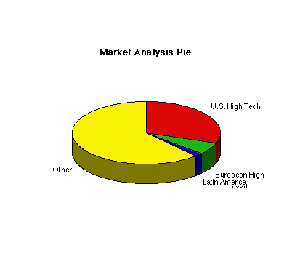
Potential Customers Customers Growth rate
____________________________________________________
U.S. High Tech 5,000 10%
European High Tech 1,000 15%
Latin America 250 35%
Other 10,000 2%
____________________________________________________
Total 16,250 n.a.

5. 0 Strategy Summary
Acme will focus on three geographical markets, the United States,Europe, and Latin America, and in limited product segments: personal computers, software, networks, telecommunications, personal organizers, and technology integration products. The target customer is usually a manager in a larger corporation, and occasionally an owner or president of a medium-sized corporation in a high-growth period.

5. 1 Pricing Strategy
Acme Consulting will be priced at the upper edge of what the market will bear, competing with the name brand consultants. The pricing fits with the general positioning of Triangle as high-level expertise.
Consulting should be based on $5,000 per day for project consulting, $2,000 per day for market research, and $10,000 per month and up for retainer consulting. Market research reports should be priced at $5,000 per report, which will of course require that reports be very well planned, focused on very important topics very well presented.

5. 2 Sales Forecast
The sales forecast monthly summary is included in the appendix. The annual sales projections are included here in the following table.
Sales Forecast

Sales 1995 1996 1997
__________________________________________________________________
Retainer Consulting $200,000 $250,000 $325,000
Project Consulting $270,000 $325,000 $350,000
Market Research $122,000 $150,000 $200,000
Strategic Reports $0 $50,000 $125,000
Other $0 $0 $0
Total Sales $592,000 $775,000 $1,000,000

Cost of sales 1995 1996 1997
__________________________________________________________________
Retainer Consulting $30,000 $20,000 $30,000
Project Consulting $45,000 $25,000 $31,000
Market Research $84,000 $45,000 $50,000
Strategic Reports $0 $20,000 $40,000
Other $0 $0 $0
Total Cost of Sales $159,000 $110,000 $151,000
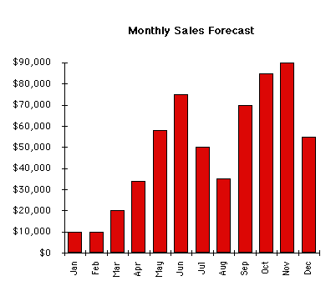
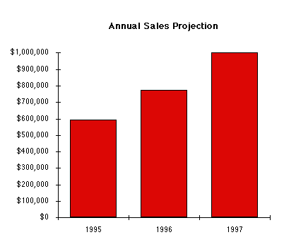

5. 3 Strategic Alliances
At this writing strategic alliances with Smith and Jones are possibilities, given the content of existing discussions. Given the background of prospective partners, we might also be talking to European companies including Siemens and Olivetti and others, and to United States companies related to Apple Computer. In Latin America we would be looking at the key local high-technology vendors, beginning with Printaform.

6. 0 Management Summary
The initial management team depends on the founders themselves, with little back-up. As we grow we will take on additional consulting help, plus graphic/editorial, sales, and marketing.

6. 1 Organizational Structure
Acme should be managed by working partners, in a structure taken mainly from Smith Partners. In the beginning we assume 3-5 partners:
- Ralph Sampson
- At least one, probably two partners from Smith and Jones
- One strong European partner, based in Paris.
The organization has to be very flat in the beginning, with each of the founders reponsible for his or her own work and management.
- One other strong partner

6. 2 Management Team
The Acme business requires a very high level of international experience and expertise, which means that it will not be easily leveragable in the common consulting company mode in which partners run the business and make sales, while associates fulfill. Partners will necessarily be involved in the fulfillment of the core business proposition, providing the expertise to the clients.
The initial personnel plan is still tentative. It should involve 3-5 partners, 1-3 consultants, 1 strong editorial/graphic person with good staff support, 1 strong marketing person, an office manager, and a secretary. Later we add more partners, consultants and and sales staff.
Founders' resumes are included as an additional attachment to this plan.

6. 3 Personnel Plan
The detailed monthly personnel plan for the first year is included in the appendices. The annual personal estimates are included here as Table 5.
Personnel Plan
1995 1996 1997
_________________________________________________________________

Partners $144,000 $175,000 $200,000
Consultants $0 $50,000 $63,000
Editorial/graphic $18,000 $22,000 $26,000
VP Marketing $20,000 $50,000 $55,000
Sales people $0 $30,000 $33,000
Office Manager $7,500 $30,000 $33,000
Secretarial $5,250 $20,000 $22,000
Other $0 $0 $0
Subtotal $194,750 $377,000 $432,000

7. 0 Financial Plan
We will maintain a conservative financial strategy, based on developing capital for future growth.

7. 1 Important Assumptions
The table in this section summarizes key financial assumptions, including 45-day average collection days, sales entirely on invoice basis, expenses mainly on net 30 basis, 35 days on average for payment of invoices, and present-day interest rates.
General Assumptions

1995 1996 1997
______________________________________________________________________
___

Collection days 43 45 45
Payment Days 35 35 35

1995 1996 1997
______________________________________________________________________
___
Short Term Interest Rate 8.00% 8.00% 8.00%
Long Term Interest Rate 10.00% 10.00% 10.00%
Payment days 35 35 35
Tax Rate Percent 0.00% 0.00% 0.00%
Expenses in cash% 25.00% 25.00% 25.00%
Sales on credit 100.00% 100.00%
100.00%
Personnel Burden % 14.00% 14.00%
14.00%

7.2 Key Financial Indicators
The chart summarizes key financial benchmarks. Unfortunately, as we increase sales we will have to show a decline in performance of collection days and gross margin.
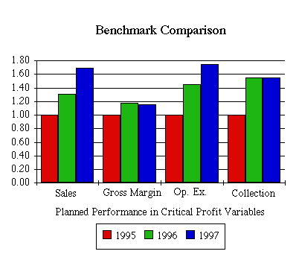

7. 3 Break-even Analysis
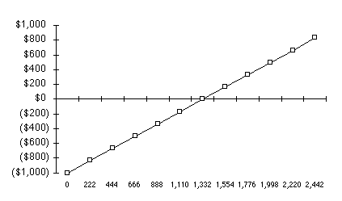
Break Even Analysis:
___________________________________________________
Monthly Units Break-even 125,000
Monthly Sales Break-even $125,000

Assumptions:
Average Unit Sale $1.00
Average Per-Unit Cost $0.20
Fixed Cost $100,000

7. 4 Projected Profit and Loss
The detailed monthly pro-forma income statement for the first year is included in the appendices. The annual estimates are included here.
Pro-forma Income Statement
1995 1996 1997
______________________________________________________________________
___
Sales $592,000 $775,000
$1,000,000
Cost of Sales $159,000 $110,000
$151,000
Other $1,000 $0 $0

_________________________________________________

Total Cost of Sales $160,000 $110,000
$151,000
Gross margin $432,000 $665,000
$849,000
Gross margin percent 72.97% 85.81% 84.90%
Operating expenses:
Advertising/Promotion 10.00% $36,000 $40,000
$44,000
Public Relations 10.00% $30,000 $30,000
$33,000
Travel 10.00% $90,000 $60,000
$110,000
Miscellaneous 10.00% $6,000 $7,000 $8,000
Payroll expense $194,750 $377,000
$432,000
Leased Equipment $6,000 $7,000 $7,000
Utilities 20% $12,000 $14,000
$17,000
Insurance 20% $3,600 $2,000 $2,000
Depreciation $0 $0
$0
Rent 25% $18,000 $23,000
$29,000
Payroll Burden $0 $0 $0
Contract/Consultants $0 $0 $0
Other $0 $0 $0

_________________________________________________

Total Operating Expenses $396,350 $560,000
$682,000
Profit Before Interest and Taxes$35,650 $105,000
$167,000
Interest Expense ST $3,600 $12,800
$12,800
Interest Expense LT $5,000 $5,000 $5,000
Taxes Incurred $0 $0 $0
Net Profit $27,050 $87,200
$149,200
Net Profit/Sales 4.57% 11.25%
14.92%

7. 5 Projected Cash Flow
Cash flow projections are critical to our success. The monthly cash flow is shown in the illustration, with one bar representing the cash flow per month and the other the monthly balance. The annual cash flow figures are included here. Detailed monthly numbers are included in the appendices.
Pro-Forma Cash Flow
1995 1996
1997
______________________________________________________________________
______________
Net Profit: $27,050 $87,200
$149,200
Plus:
Depreciation $0 $0
$0
Change in Accounts Payable $49,413 $16,799
$13,764
Current Borrowing (repayment) $60,000 $100,000
$0
Increase (decrease) Other Liabilities $0 $0
$0
Long-term Borrowing (repayment) $50,000 $0
$0
Capital Input $0 $0
$0
Subtotal $186,463 $203,999
$162,964
Less: 1905 1905
1905
Change in Accounts Receivable $94,000 $5,750
$50,500
Change in Inventory $0 $0
$0
Change in Other ST Assets $0 $0
$0
Capital Expenditure $0 $0
$0
Dividends $0 $0
$0
Subtotal $94,000 $5,750
$50,500
Net Cash Flow $92,463 $198,249
$112,464
Cash balance $117,463 $315,712
$428,176
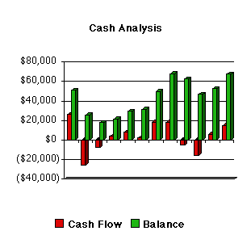

7. 6 Projected Balance Sheet
The balance sheet shows healthy growth of net worth, and strong financial position. The monthly estimates are included in the appendices.
Pro-forma Balance Sheet
1995 1996
1997
______________________________________________________________________
______________
Short-term Assets Starting Balances
Cash $25,000 $117,463 $315,712
$428,176
Accounts receivable $0 $94,000 $99,750 $150,250
Inventory $0 $0 $0
$0
Other Short-term Assets $7,000 $7,000 $7,000
$7,000
Total Short-term Assets $32,000 $218,463 $422,462
$585,426
Long-term Assets
Capital Assets $0 $0 $0
$0
Accumulated Depreciation$0 $0 $0
$0
Total Long-term Assets $0 $0 $0
$0

_________________________________________________
Total Assets $32,000 $218,463 $422,462
$585,426

Debt and Equity
1995 1996
1997
______________________________________________________________________
______________
Accounts Payable $5,000 $54,413 $71,212
$84,976
Short-term Notes $0 $60,000 $160,000
$160,000
Other ST Liabilities $0 $0 $0
$0
Subtotal Short-term Liabilities
$5,000 $114,413 $231,212
$244,976

Long-term Liabilities $0 $50,000 $50,000
$50,000
Total Liabilities $5,000 $164,413 $281,212
$294,976

Paid in Capital $50,000 $50,000 $50,000
$50,000
Retained Earnings ($23,000) ($23,000) $4,050
$91,250
Earnings $0 $27,050 $87,200
$149,200
Total Equity $27,000 $54,050 $141,250
$290,450
Total Debt and Equity $32,000 $218,463 $422,462
$585,426
Net Worth $27,000 $54,050 $141,250
$290,450

7. 7 Business Ratios
Acme Consulting will be formed as a consulting company specializing in marketing of high-technology products in international markets. Its founders are former marketers of consulting services, personal computers, and market research, all in international markets. They are founding Acme to formalize the consulting services they offer.
Ratio Analysis

Profitability Ratios: 1995 1996 1997
____________________________________________________________________
Gross margin 72.97% 85.81% 84.90%
Net profit margin 4.57% 11.25% 14.92%
Return on Assets 12.38% 20.64% 25.49%
Return on Equity 50.05% 61.73% 51.37%

Activity Ratios:
AR Turnover 6.30 7.77 6.66
Collection days 29 45 45
Inventory Turnover 0.00 0.00 0.00
Accts payable turnover 7.67 7.06 7.35
Total asset turnover 2.71 1.83 1.71

Debt Ratios: 1995 1996 1997
____________________________________________________________________
Debt to net Worth 3.04 1.99 1.02
Short-term Debt to Liab. 0.70 0.82 0.83

Liquidity Ratios:
Current Ratio 1.91 1.83 2.39
Quick Ratio 1.91 1.83 2.39
Net Working Capital $104,050 $191,250
$340,450
Interest Coverage 4.15 5.90 9.38

Additional Ratios: 1995 1996 1997
____________________________________________________________________
Assets to sales 0.37 0.55 0.59
Debt/Assets 75% 67% 50%
Current debt/Total Assets 52% 55% 42%
Acid Test 1.09 1.40 1.78
Asset Turnover 2.71 1.83 1.71
Sales/Net Worth 10.95 5.49 3.44

Appendices
The appendices to this plan include:
- Complete financial results including accountantsÕ statement and copies of tax forms for past years.
- Complete set of sales literature, brochures, catalogs, etc.
- Resumes from key managers
- Detailed monthly pro forma sales forecast, personnel plan, profit and loss, cash flow, and balance sheet. Important: months are not all shown in this sample plan, because of page format constraints. Business Plan Pro normally prints appendices in landscape mode, so it can show all the months.
Sales Forecast in Detail 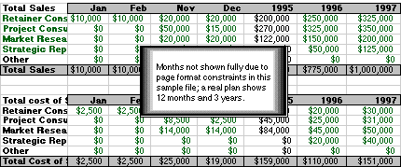
Personnel Plan in Detail 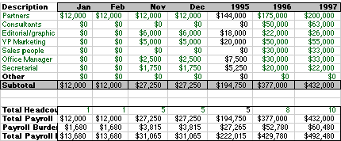
Profit and Loss Projection in Detail 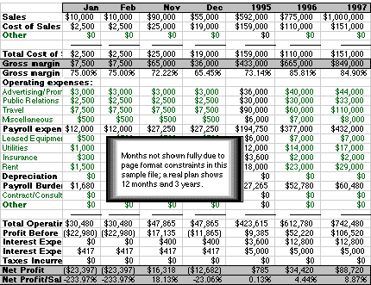
Cash Flow Projection in Detail 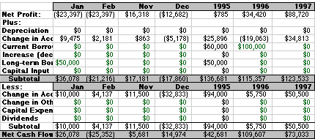
Projected Balance Sheet in Detail 